Year 9 Science
Biological Sciences
Worksheet - Symbiotic Relationships

Identify the type of relationship in each picture below and justify your answer by describing how each organism benefits.
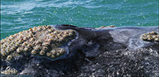
Relationship:

Reason:

Barnacles on a whale.

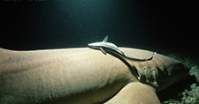
Relationship:

Reason:

Nurse shark with remoras.

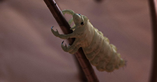
Relationship:

Reason:

Human head louse.


Relationship:

Reason:

Students doing homework together.


Relationship:

Reason:

Student copying classmate's work.


Relationship:

Reason:

Teenage student bullying a classmate and
stealing his lunch money.

